**INVENTORY MANAGEMENT FOR RETAILERS:**

**ASSIGNMENT 4**

**1.Pull an Image from docker hub and run it in docker playground.**

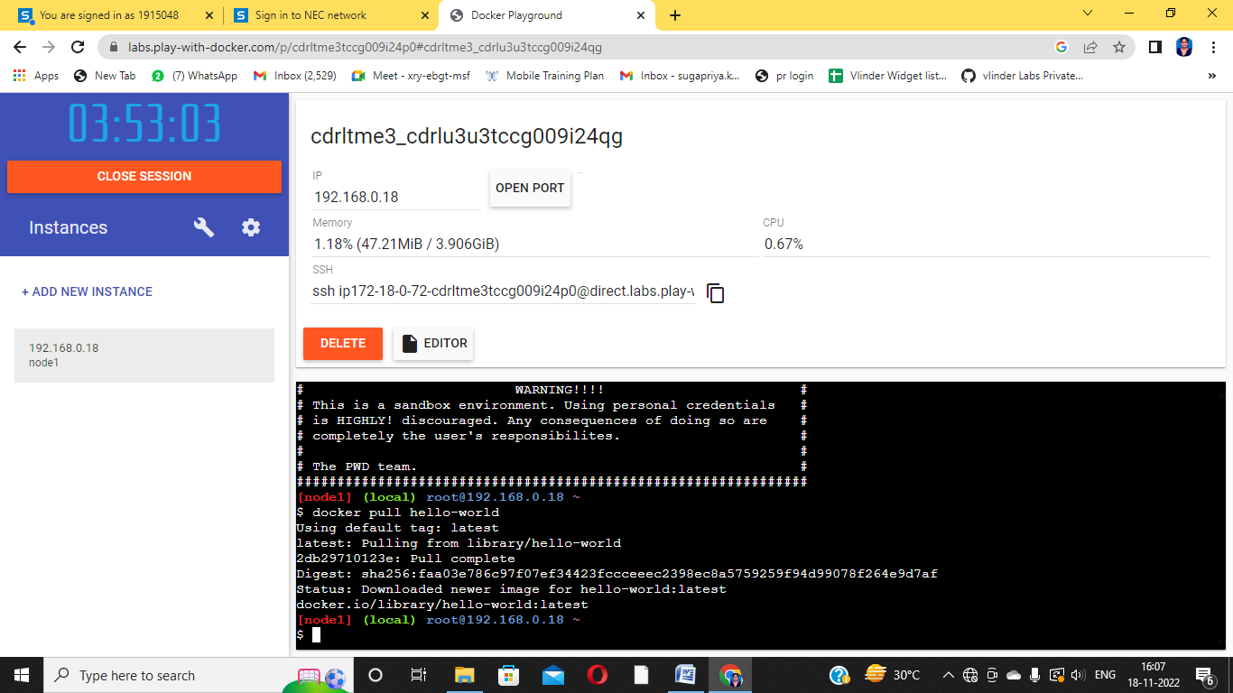

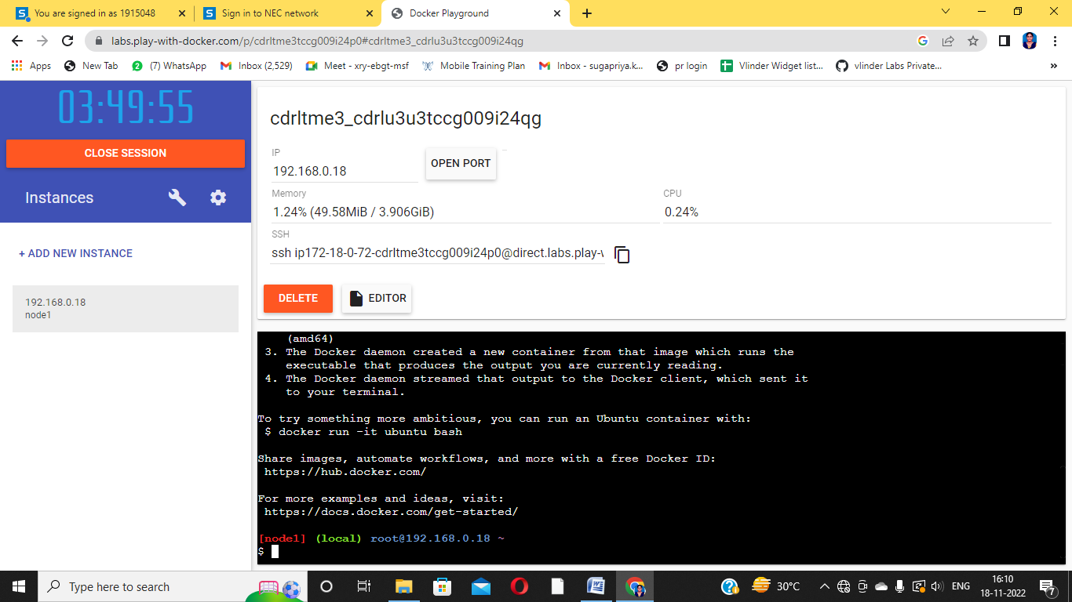

**2.Create a docker file for the jobportal application and deploy it in Docker desktop application.**

FROM python:3.7

COPY. /app

WORKDIR /app

COPY requirements.txt /app

RUN python -m pip install -r requirements.txt

EXPOSE 5001

ENTRYPOINT [ "python" ]

CMD [ "app.py" ]

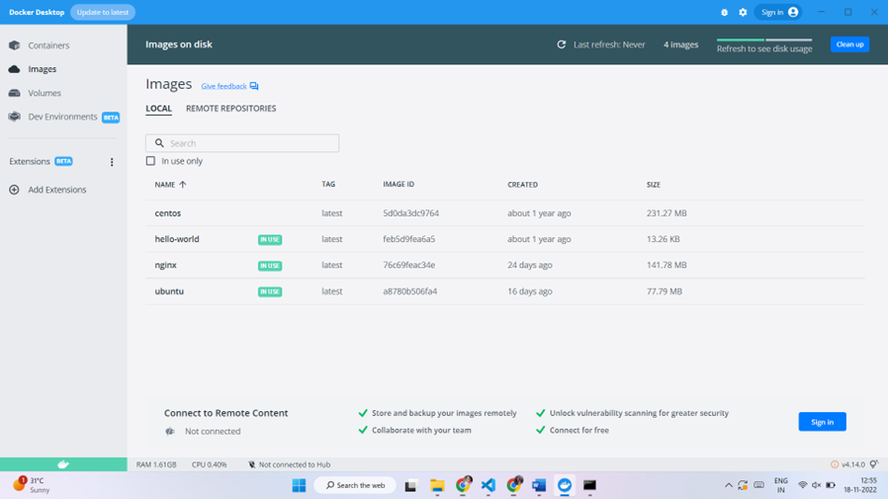

**3.Create a IBM container registry and deploy helloworld app orjobportalapp.**

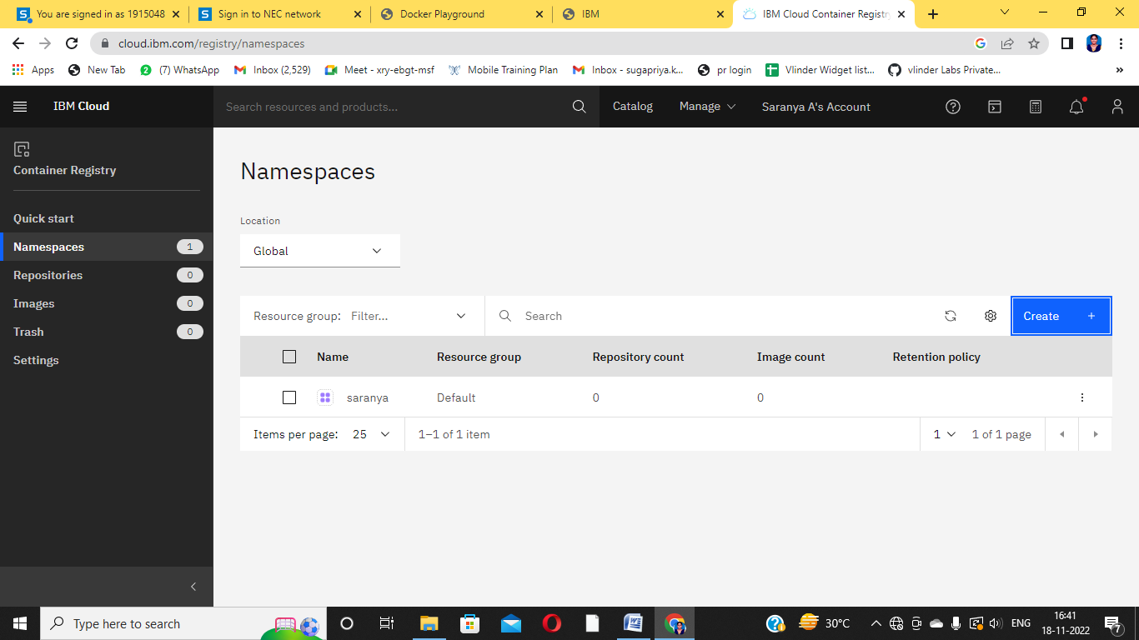

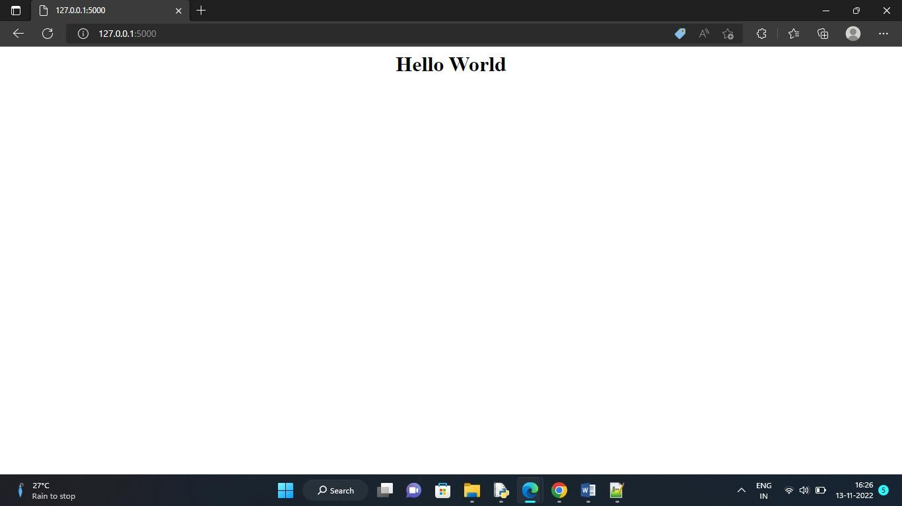

**4.Create a Kubernetes cluster in IBM cloud and deploy helloworld image or jobportal image and also expose the same app to run in nodeport.**

